## Major Project Report

***on***

**ONLINE EXAMINATION SYSTEM**

***In partial fulfillment of requirements for the degree***

***of***

**BACHELOR OF TECHNOLOGY**

**IN**

**INFORMATION TECHNOLOGY**

***Submitted by:***

Rishabh Raj [19100BTIT06601]

Rishabh Patidar [19100BTIT06599]

Sachin Kumar kodli [19100BTIT06607]

Prashant Vishwakarma [19100BTIT06591]

***Under the guidance of***

PROF. Priyanka Gupta (Guide)

PROF. Rashmi Chouhan (Co-Guide)



**SHRI VAISHNAV VIDYAPEETH VISHWAVIDYALAYA, INDORE**

**SHRI VAISHNAV INSTITUTE OF INFORMATIN TECHNOLOGY**

**DEPARTMENT OF INFORMATION TECHNOLY**

**JULY-DEC 2022**

**SHRI VAISHNAV VIDYAPEETH VISHWAVIDYALAYA, INDORE**

**SHRI VAISHNAV INSTITUTE OF INFORMATION TECHNOLOGY**

**DEPARTMENT OF INFORMATION TECHNOLOGY**

**DECLARATION**

We here declare that work which is being presented in the project entitled **“ONLINE EXAMINATION SYSTEM”** in partial fulfillment of degree of **Bachelor of Technology in Information Technology** is an authentic record of our work carried out under the supervision and guidance of **Mrs. Priyanka Gupta & Mrs. Rashmi Chouhan** Asst. Professor of Information Technology. The matter embodied in this projecthas not been submitted for the award of any other degree.

Date: -

Rishabh Raj [19100BTIT06601] Signature:

Rishabh Patidar [19100BTIT06599] Signature:

Sachi Kumar kodli [19100BTIT0660] Signature:

Prashant Vishwakarma [19100BTIT06591] Signature:

**SHRI VAISHNAV VIDYAPEETH VISHWAVIDYALAYA, INDORE**

**SHRI VAISHNAV INSTITUTE OF INFORMATION TECHNOLOGY**

**DEPARTMENT OF INFORMATION TECHNOLOGY**

**PROJECT APPROVAL SHEEET**

Following team has done the appropriate work related to the “**ONLINE EXMAINATION SYSTEM**” in partial fulfillment for the award of **Bachelor of Technology in Information** **Technology** of “SHRI VAISHNAV INSTITUTE OF INFORMATION TECHNOLOGY” andis being submitted to SHRI VAISHNAV VIDYAPEETH VISHWAVIDYALAYA, INDORE.

**Team:**

Rishabh Raj [19100BTIT06601]

Rishabh Patidar [19100BTIT06599]

Sachin Kumar kodli [19100BTIT06607]

Prashant Vishwakarma [19100BTIT06591]

**Internal Examiner** **External Examiner**

Date

**SHRI VAISHNAV VIDYAPEETH VISHWAVIDYALAYA, INDORE**

**SHRI VAISHNAV INSTITUTE OF INFORMATION TECHNOLOGY**

**DEPARTMENT OF INFORMATION TECHNOLOGY**

**CERTIFICATE**

This is to certify that **Mr. Rishabh Raj**, **Mr. Rishabh Patidar** **Mr. Sachin Kumar Kodli** and **Mr. Prasant Vishwakarma** working in a team have satisfactorily completed the project entitled “**ONLINE EXAMINATION SYSTEM**” under the guidance of **Mrs. Priyanka Gupta & Mrs. Rashmi Chouhan** in the partial fulfillment of the degree of **Bachelor of Technology in Information Technology** awarded by SHRI VAISHNAV INSTITUTE OF INFORMATION TECHNOLOGY affiliated to SHRI VAISHNAV VIDYAPEETH VISHWAVIDYALAYA, INDORE during the academic year **July** **-Dec (2022).**

|  |
| --- |
| Prof. Priyanka Gupta |
| **Project Guide** |

|  |
| --- |
| Prof. Rashmi Chouhan |
| **Project Co-Guide** |

|  |
| --- |
| Prof. Rahul Choudhary |
| **Project Coordinator** |

Dr. Jigyasu Dubey

**HOD, IT** **Department****s**

**ACKNOWLEDGEMENT**

We are grateful to a number of persons for their advice and support during the time of complete our project work. First and foremost, our thanks go to **Dr. Jigyasu Dubey** Head of the Department of Information Technology and **Mrs. Priyanka Gupta** the mentor of our project for providing us valuable support and necessary help whenever required and also helping us explore new technologies by the help of their technical expertise. His direction, supervision and constructive criticism were indeed the source of inspiration for us.

We would also like to express our sincere gratitude towards our Director **Dr. Anand Rajavat** for providing us valuable support.

We are really indebted to **Prof. Rahul Choudhary,** project coordinator for helping us in each aspect of our academic’s activities. We also owe our sincere thanks to all the **faculty members** of Information Technology Department who have always been helpful.

We forward our sincere thanks to all **teaching and non-teaching staff** of Information Technology department, SVVV Indore for providing necessary information and their kind co-operation.

We would like to thanks our parents and family members, our classmates and our friends for their motivation and their valuable suggestion during the project. Last, but not the least, we thank all those people, who have helped us directly or indirectly in accomplishing this work. It has been a privilege to study at SHRI VAISHNAV VIDYAPEETH VISHWAVIDYALAYA, INDORE.

**ABSTRACT**

Online examination helps Rodents of schools/ College/ Institutes is to offer a quick and easy way to appear for the exam. It also provides the results immediately after the exam. The students have to enter valid user-id and password to attend the exam. This examination project provides time limit to finish the exam. The user can see their results after completing the exam. The purpose of this project is to develop Online Examination System. This is a web based Online Examination System which will help in conducting the Online Examination. The Online Examination System project provides a web application which will considerably reduce the time required to give the exam and know the results. This project will provide an efficient platform both for the students and the teachers, by enabling examinations to be taken online. An Online Examination System is a special type of web-based application where examinations of the students can be taken in a correct and efficient manner. Online Examination System consists of some pages of questions and the student has to write answers or they have to select the correct answers of those questions by selecting appropriate choice.

**LIST OF FIGURES**

|  |  |  |
| --- | --- | --- |
| **S.NO** | **DESCRIPTION** | **PAGE NO** |
| 4.3.2 | Use case diagram | **21** |
| 4.3.3 | DFD level 0 | **22** |
| 4.3.4. | DFD level 1 | **23** |
| 5.1 | Class diagram | **24** |
| 5.2 | Sequence diagram | **25** |
| 5.3 | State diagram | **26** |
| 5.4 | Activity diagram | **27** |
| 5.6.1 | User login window | **30** |
| 5.6.2 | Student signup page | **31** |
| 5.6.3 | Admin login panel | **31** |
| 5.6.4 | Teacher login panel | **32** |
| 5.6.5 | Admin Dashboard | **32** |

**TABLE OF CONTENT**

**TITLE PAGE NO**

Declaration 2

Project Approval Sheet 3

Certificate 4

Acknowledgement 5

Abstract 6

List of Figures 7

CHAPTER 1 **– INTRODUCTION 10-11**

* 1. Introduction 10
  2. Problem Statement 10
  3. Need for Proper System 10
  4. Objective 11
  5. Module of the system 11
  6. Scope 11

CHAPTER 2 **- LITRETUARE SURVEY 12-13**

|  |
| --- |
| 12 |
| 12 |
| 12 |
| 13 |
| 13 |
| 13 |

* 1. Existing System

2.2Proposed System

2.3Feasibility Study

* 1. Technical Feasibility

2.3.2Economical Feasibility

2.3.3Operational Feasibility

CHAPTER 3 – **REQUIREMENTS ANALYSIS 14-16**

|  |  |
| --- | --- |
| 3.1 Methods used for Requirement Analysis | 14 |
| 3.2 Data Requirements | 14 |
| 3.3 Functional Requirements | 15 |
| 3.4 Non-Functional Requirements | 15 |
| 3.5 System Specification | 16 |
| 3.5.1 Hardware Specification | 16 |
| 3.5.2 Software Specification | 16 |

CHAPTER 4 **- DESIGN 17-21**

|  |  |
| --- | --- |
| 4.1 System Design | 17 |
| 4.2 Design Technique | 17 |
| 4.3 Software Requirements Specification | 18 |
| 4.3.1 Glossary | 18 |
| 4.3.2 Use Case Model | 19 |
| 4.3.3 DFD level 0 | 20 |
| 4.3.4 DFD level 1 | 21 |

CHAPTER 5 **– SYSTEM MODELING 22-30**

|  |  |
| --- | --- |
| 5.1 Detailed Class Diagram | 22 |
| 5.2 Sequence Diagram | 23 |
| 5.3 State Diagram | 24 |
| 5.4 Activity Diagram | 25 |
| 5.5 Test Plans and Implementation Images | 26 |
| 5.6 Screenshots | 27 |
| 5.7 Functional Programming | 30 |

CHAPTER 6 **– CONCLUSION AND FUTURE WORK 31-32**

|  |  |
| --- | --- |
| 6.1 Conclusion | 31 |
| 6.2 Limitation of Project | 31 |
| 6.3 Future Enhancement | 32 |

CHAPTER 7 **- BIBLIOGRAPHY & REFERENCES 33**

|  |  |
| --- | --- |
| * 1. Reference Books | 33 |
| * 1. Other Documentations & Resources | 33 |

**INTRODUCTION CHAPTER 1**

**1.1 Introduction**

Moving on, this online exam system project in Python Django focuses mainly on dealing with student’s examinations. Also, the system displays all the available course and their question sets. In addition, the system allows managing question set by entering questions, options, and answers. This project is divided into three categories: Student, Teacher, and Admin Panel. In an overview of this web application, a student can simply register and start using it. Here, the system displays all the exams for the student. And the student can proceed to attend their examinations. All the exams are of MCQ type. After submission of answers, the student can view his/her marks with their number of attempts under respective courses. The system also counts the number of attempts a student takes in order to complete the exam.

**1.2 Problem statement**

Problem**s** of online examination this system allows candidates to register and take an examination in the system. The Lecturer of this system is allowed to login for contributing questions and viewing profile of candidates. Administrators will be able to access the system to sign up to a new. Online Examination, manage questions, accounts and view profile of the candidates. I will borrow a host for implementation our system. Our group will keep the existing online examination catalog database by using Microsoft access to access database.

At the online examination, guest must register an account to become a candidate by fill all required information such as name, birthday. Once the registration process is completed for a guest, the registration system sends information to the billing system so the guest can be logged in the system. After that, the system will allow candidate to login and select a department for examining. Every time, the candidates will be able to view their profile. The Instructor or Lecturer must be able to access the online system to contribute questions. They also can view the profile of candidates. The administrator manages operation of the system such as managing accounts and questions, viewing profile of candidates.

**1.3 Need to the new system**

Scalable With Worldwide Reach: With online assessment, examining bodies can offer exams to candidates located over greater geographical areas, as they are not restricted to offering exams in physical test centers. This enables development for student learning across the world, which is the beginning of mass learning. Ensuring students are not limited to the tests that they can take, enhances the chance of education for those that seek further education development and new knowledge.

**1.4 Objective**

The purpose of this project is to develop Online Examination System. This is a web based Online Examination System which will help in conducting the Online Examination. The Online Examination System project provides a web application which will considerably reduce the time required to give the exam and know the results. This project will provide an efficient platform both for the students and the teachers, by enabling examinations to be taken online. An Online Examination System is a special type of web-based application where examinations of the students can be taken in a correct and efficient manner. Online Examination System consists of some pages of questions and the student has to write answers or they have to select the correct answers of those questions by selecting appropriate choice.

**1.5 Modules of the system**

* Mark module: It contain all the functionalities related to the marks.
* Students’ module: It manages all operations related to the students.
* Examinations module: It manages examinations related all functionalities.
* Faculties module: It manage all functionalities related to faculties.
* Courses module: Courses module contains all the required functions which include viewing, deleting, updating and adding course list.

**1.6 Scope**

* In computer system the person has to fill various forms and numbers of copies of the form can be easily generated at a time.
* To assist the staff in capturing the effort spent on their respective working areas.
* It satisfies the user requirement.
* Be easy to understand by user and operator.
* Have a good user interface.
* Be expandable.
* To utilize resources in an efficient manner by increasing their productivity through automation.

**LITERATURE SURVEY CHAPTER 2**

**2.1 Existing System**

Existing system is a manual one in which users are maintaining books to store the information like Student Details, Instructor Details, Schedule Details and feedbacks about students who attempted exam as per schedule. It is very difficult to maintain historical data.

The following drawbacks of existing system emphasize the need for computerization:

1. a lot of copies of question papers have to be made.
2. a lot of correction work hence delays in giving the results.
3. a lot of tabulation works for each subject results.

**2.2 Proposed System**

This application is used to conduct online examination. The students can sit at individual terminals and login to write the exam in the given duration. The questions have to be given to the students. This application will perform correction, display the result immediately and also store it in database. This application provides the administrator with a facility to add new exams. This application provides the instructor add questions to the exam, modify questions in the exam in a particular exam. This application takes care of authentication of the administrator, Instructor as well as the student.

**2.3 Feasibility Study**

Feasibility study includes consideration of all the possible ways to provide a solution to the given problem. The proposed solution should satisfy all the user requirements and should be flexible enough so that future changes can be easily done based on the future upcoming requirements.

The main aim of the study was to find out the viability and practicability of undertaking this project. The following were the outcomes of the study: -

**2.3.1 Technical Feasibility**

* Availability of the necessary hardware for the development: The minimum hardware environment needed includes a Pentium iv (any speed) processor.
* 4 GB RAM, 8 GB Hard Disk space and proper peripherals like Colored monitor, Keyboard and Mouse.
* However, the proposed system is to be developed under a much higher hardware platform.
* Thus, there is no question the project will face any technical problems during coding and testing phases. Thus, considering hardware availability it could be considered that the proposed system is technically feasible for development.

**2.3.2 Economical Feasibility**

The cost of running this project from start to finish was affordable. From the cost/benefit analysis carried out, it was determined that the benefits of this system outweighed its cost by a good margin. Overall, we have estimated that the benefits the organization is going to receive from the proposed system will surely overcome initial costs and the layer on running cost for system.

**2.3.3 Operational Feasibility**

The system’s operation was determined to be feasible because it would solve user problems by providing a cheap and reliable advertising platform. It lets the different users and organization shave control of their information and how the system handles their Information.

**REQUIREMENTS ANALYSIS CHAPTER 3**

**3.1 Methods used for Requirement Analysis**

* **Draw the context diagram:** The context diagram is a simple model that defines the boundaries and interfaces of the proposed systems with the external world. It identifies the entities outside the proposed system that interact with the system.
* **Development of a Prototype (optional):** One effective way to find out what the customer wants is to construct a prototype, something that looks and preferably acts as part of the system they say they want.
* **Model the requirements:** This process usually consists of various graphical representations of the functions, data entities, external entities, and the relationships between them. The graphical view may help to find incorrect, inconsistent, missing, and superfluous requirements. Such models include the Data Flow diagram, Entity-Relationship diagram, Data Dictionaries, State-transition diagrams, etc.
* **Finalize the requirements:** After modeling the requirements, we will have a better understanding of the system behavior. The inconsistencies and ambiguities have been identified and corrected. The flow of data amongst various modules has been analyzed. Elicitation and analyze activities have provided better insight into the system. Now we finalize the analyzed requirements, and the next step is to document these requirements in a prescribed format.

**3.2 Data Requirements**

* Support high concurrency ；
* To enable students to take exams anytime and anywhere;
* Realize the function of adding test questions and test paper online;
* Support test questions management, test paper management, easy to classify management;
* Add candidates online and manage candidate information;
* Achieve candidates’ online answering on multiple platforms, such as computer and mobile phones;
* Realize automatic judgment and reduce manual output;

**3.3 Functional Requirements**

The analysis of the specific functional requirements for the system is as follows:

# 3.3.1 User login

* **Student login:** Enter student ID, password correctly, log in, and enter the student examination page.
* **Teacher login**: Enter the sign, password correctly, log in, enter the teacher management page, the course information management, examination question bank management and artificial marking examination papers.
* **Administrator login**: Enter the user’s name, password and verification code correctly, log in, and enter the backstage page.

# 3.3.2 Backstage management

# User management: Manage student information, teacher information and administrator information, including the operation of adding, modifying, deleting, and querying.

* **Examination paper management**: according to the examination subjects to carry out the examination papers, the type of examination paper is divided into two types of objective questions and subjective questions
* **Examination questions management:** manage various types of test questions, including the operation of adding, modifying, deleting, and inquiring for single choice, multiple choice.

## 3.4 Non-Functional Requirements

## 3.4.1 Performance Requirements

Some Performance requirements identified is listed below:

* The performance of the system should be fast and accurate.
* The system should be able to handle large amount of data. Thus, it should accommodate high details without any fault.

There are no other specific performance requirements that will affect development.

## 3.4.2 Safety Requirements

As a part of the safety requirement, we prefer to keep a backup of the system generated data in any external device.

## 3.4.3 Security Requirements

The system will have details of the students such as their enrollment number, name, and images that were used for training purposes, so here the admin must make sure that the database is kept safe and confidential in order to maintain the data integrity and confidentiality.

## 3.5 System Specification

It describes which type of system components requirement for run these projects.

**3.5.1 Hardware specification**

Processor: - Pentium iv

Ram: - 4GB

Hard disk: - 256 GB

Monitor: - 15” color monitor

**3.5.2 Software specification**

Operating System: - windows, Linux

Language: - python

Data base: - My SQL

Server: - Any of Mozilla, chrome, opera etc.

**DESIGN CHAPTER 4**

**4.1 System Design: -** The system design develops the architectural detail required to build a system or product. As in the case of any systematic approach, this software too has undergone the best possible design phase fine tuning all efficiency, performance and accuracy levels. The first step in system designing is to determine how the output is to be produced and in what format. In the second step, input data and master files are to be designed to meet requirement of the proposed output. The processing phases are handled through program construction and testing, including a list of the programs needed to meet the system's objectives and complete documentation.

System design is the solution to the creation of a new system. This phase is composed of several systems. This phase focuses on the detailed implementation of the feasible system. It emphasis on translating design specifications to performance specification. System design has two phases of development logical and physical design.

**4.2** **Design Technique**

* **Logical Design**

Logical design of an information system shows the major features and also how they are related to one another. The first step of the system design is to design logical design elements. This is the most creative and challenging phase and important too. Design of proposed system produces the details of the state how the system will meet the requirements identified during the system analysis that is, in the design phase we have to find how to solve the difficulties faced by the existing system. The logical design of the proposed system should include the details that contain how the solutions can be implemented.

* **Physical Design**

The process of developing the program software is referred to as physical design. We have to design the process by identifying reports and the other outputs the system will produce. Coding the program for each module with its logic is performed in this step. Proper software specification is also done in this step.

* **Input Design**

The input design is the link between the information system and the user. It comprises the developing specification and procedures for data preparation and those steps are necessary to put transaction data into a usable form for processing data entry. The activity of putting data into the computer for processing can be achieved by inspecting the computer to read data from a written or printed document or it can occur by having people keying the data directly into the system. Methods for preparing input validations and steps to follow when error occur o The samples of screen layout are given in the appendix.

* **Output Design**

Computer output is the most important and direct information source to the user. Output design is a process that involves designing necessary outputs in the form of reports that should be given to the users according to the requirements. Efficient, intelligible output design should improve.

## 4.3 Software Requirements Specification

The production of the requirements stage of the software development process is **Software Requirements Specifications (SRS)**(also called a **requirements document**). This report lays a foundation for software engineering activities and is constructing when entire requirements are elicited and analyzed**. SRS** is a formal report, which acts as a representation of software that enables the customers to review whether it (SRS) is according to their requirements. Also, it comprises user requirements for a system as well as detailed specifications of the system requirements. purpose of this SRS document is to write the functional and non-functional user or system requirements that represent the characteristics of On-Line Exam System. The scope and limitation of this system is: The on-line exam system design to educational institutes. Hold all operation and generate reports to student, teachers and administrator. Support multiple choices questions. Allow the student to prochoice the answer and to see his mark. Verify a security, authority and safety.

**4.3.1 Glossary**

Short name Description

1.OES On-line Exam System

2 On-line Exam

3 An exam written on a web site and solves the questions, also on the same web site from any place by entered user name and password. Administrator Who is responsible to create a new course, delete course, r add member or delete it, i.e.: the person who control the system Faculty A teacher in the faculty member.

**4.3.2 Use case diagram**

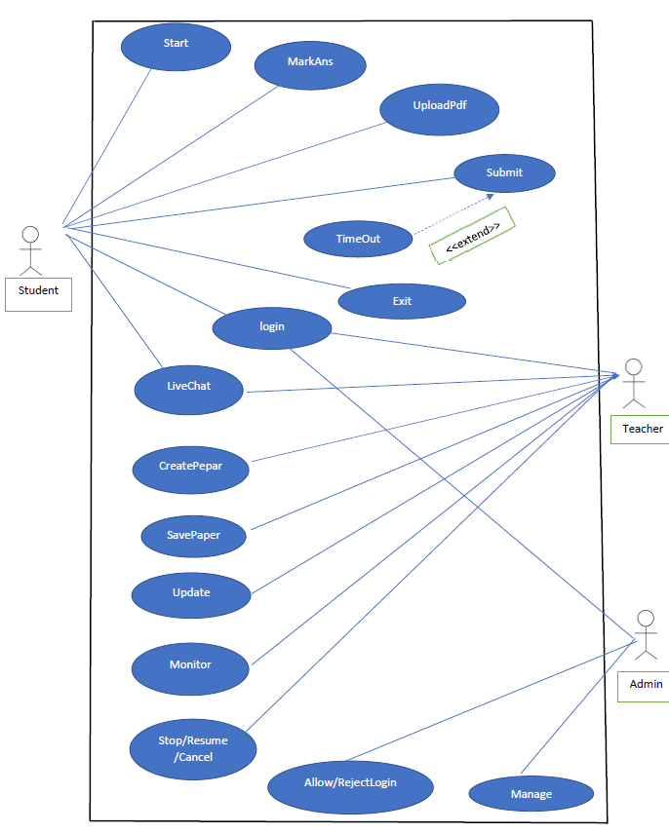

Fig 4.3.2 Use Case

**4.3.3 DFD**

A Data Flow Diagram termed as DFD, graphically representing the functions, or processes, which capture, manipulate, store, and distribute data between a system and its environment and between components of a system. The visual representation makes it a good communication tool between User and System designer. Structure of DFD allows starting from a broad overview and expand it to a hierarchy of detailed diagrams. DFD has often been used due to the following reasons: o Logical information flow of the system Determination of physical system construction requirements Simplicity of notation Establishment of manual and automated systems requirements Data flow diagrams can be divided into logical and physical. The logical data flow diagram describes flow of data through a system to perform certain functionality of a business. The physical data flow diagram describes the implementation of the logical data flow.

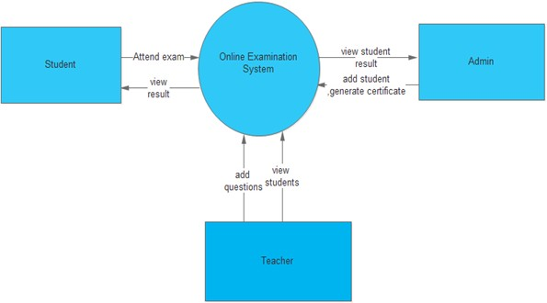

Fig 4.3.3 DFD level 0

**4.3.4 DFD level 1**

.

Fig 4.3.4 DFD level 1

**SYSTEM MODLING Chapter 5**

**5.1 Detailed Class Diagram**

A class diagram is primarily designed for developers to provide the conceptual model and architecture of the system being developed. Typically, a class diagram consists of more than one class or all the created classes for a system. It is a type of structure diagram and looks similar to a flow chart having three main parts illustrated in rectangular boxes. The first or top part specifies the class name, the second or middle specifies attributes of that class and the third or bottom section lists the methods or operations that specific class can perform.

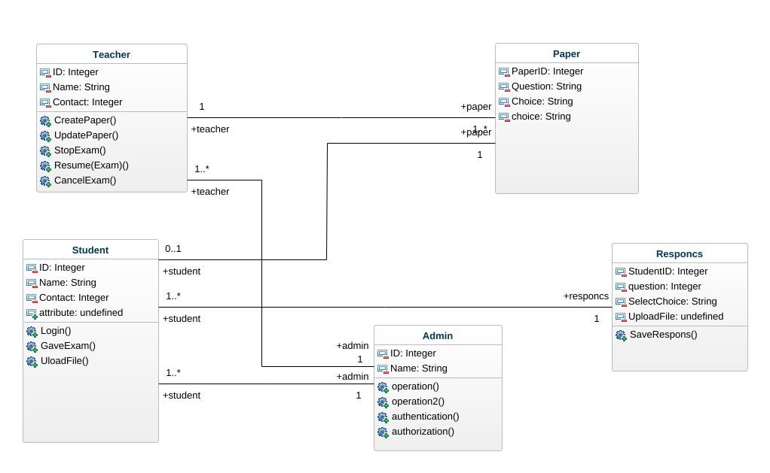

Fig 5.1 Class Diagram

**5.2 Sequence Diagram**

A class diagram is primarily designed for developers to provide the conceptual model and architecture of the system being developed. Typically, a class diagram consists of more than one class or all the created classes for a system. It is a type of structure diagram and looks similar to a flow chart having three main parts illustrated in rectangular boxes. The first or top part specifies the class name, the second or middle specifies attributes of that class and the third or bottom section lists the methods or operations that specific class can perform.

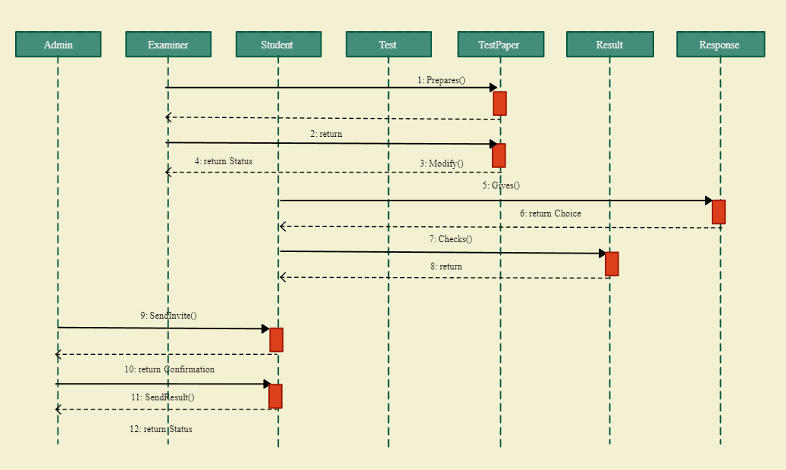

Fig 5.2 Sequence diagram

**5.3 State Diagram**



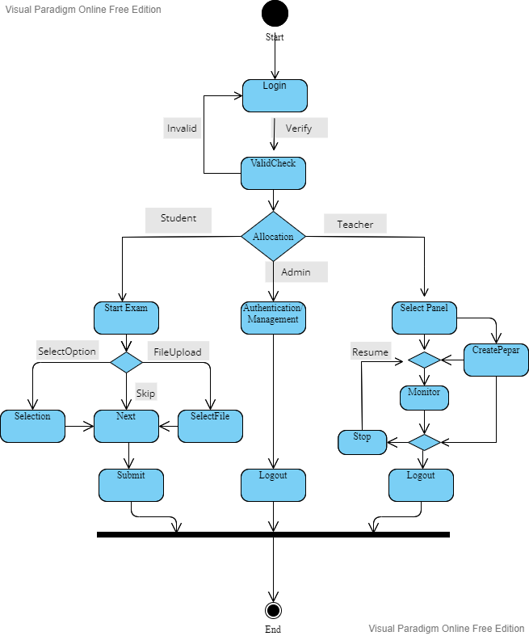



Fig 5.3 State Diagram

**5.4 Activity Diagram**

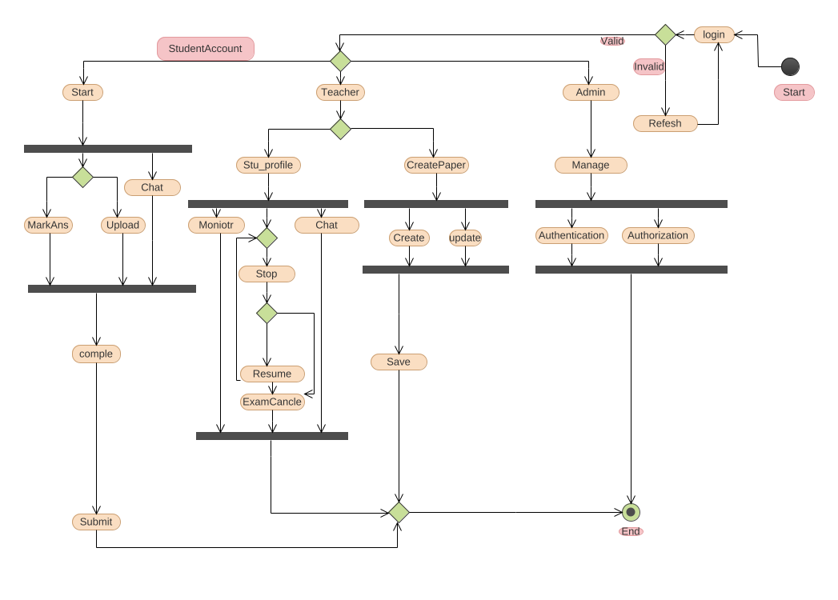

Fig 5.4 Activity Diagram

|  |  |
| --- | --- |
|  |  |

* 1. **Test Plans and Implementation Images**

**5.5.1 Test Case**

|  |  |  |  |
| --- | --- | --- | --- |
| **S.N.** | **TEST CONDITION** | **EXPECTED RESULTS** | **RESULTS** |
| 1. | When the student hits click on button “Login”. | The student login window is displayed. | Successful. |
| 2. | When the Teacher clicks on button “Login”. | The Teacher login window is displayed. | Successful. |
| 3. | When the Admin clicks on button “Login”. | The admin login window is displayed. | Successful. |

**5.5.2 Testing Objective**

Software testing is a critical element of the software development cycle. The testing is essential for ensuring the Quality of the software developed and represents the ultimate view of specification, design and code generation. Software testing is defined as the process by which one detects the defects in the software. Testing is a set of activities that work towards the integration of entire computer-based system. A good test case is one that has a high probability of finding an as-yet undiscovered error. A successful test is one such uncovers or finds such errors. If testing is conducted successfully, it will uncover errors in the software. It also demonstrates that software functions are being performed according to specifications and also behavioral and performance requirements are satisfied. For this, test plans have to be prepared. The implementation of a computer system requires that test data has to be prepared and that all the elements in the system are tested in a planned and efficient manner. Nothing is complete without testing, as it is vital success of the system.

**5.5.3 Testing Approach**

* **White Box Testing**

White box testing is the detailed investigation of internal logic and structure of the Code. To perform white box testing on an application, the tester needs to possess knowledge of the internal working of the code. The tester needs to have a look inside the source code and find out which unit/chunk of the code is behaving inappropriately.

* **Black Box Testing**

The technique of testing without having any knowledge of the interior workings of the application is Black Box testing the tester is oblivious to the system architecture and does not have access to the source code. Typically, when performing a black box test, a tester will interact with the system's user interface by providing inputs and examining outputs without knowing how and where the inputs are worked upon.

**5.6 Screenshots**

Fig 5.6 Screenshot 1

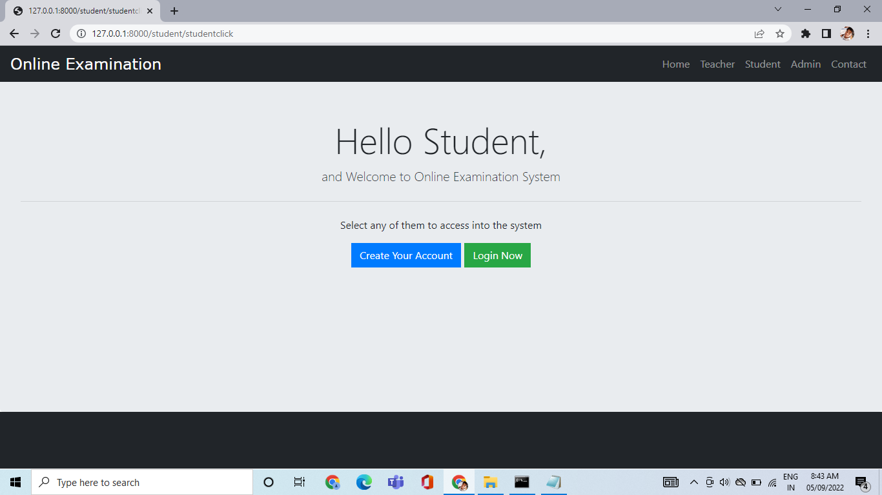

Fig 5.56 Screenshot 2

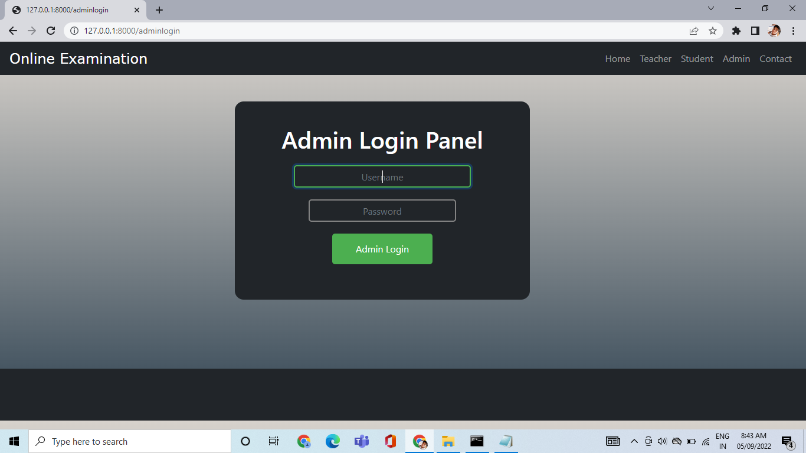

Fig 5.6 Screenshot 3

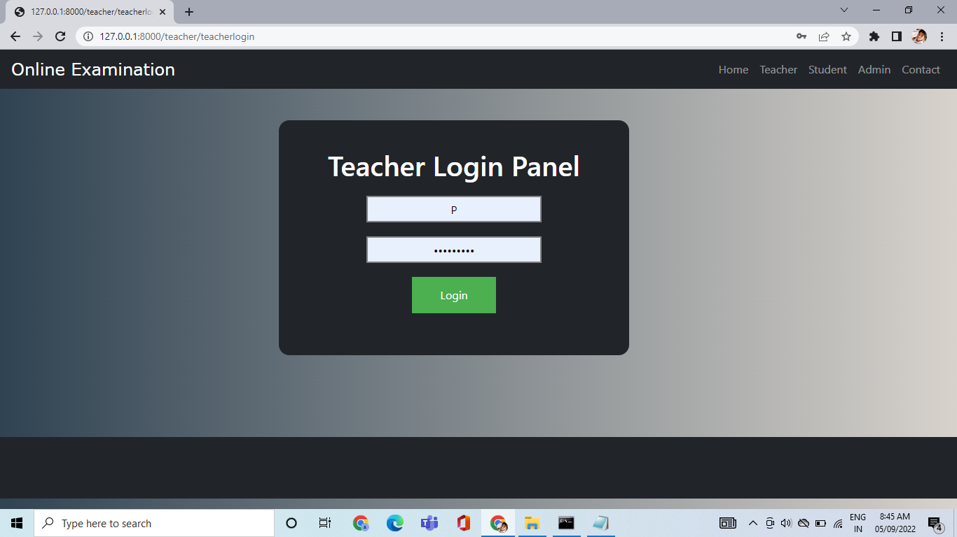

Fig 5.6 Screenshot 4

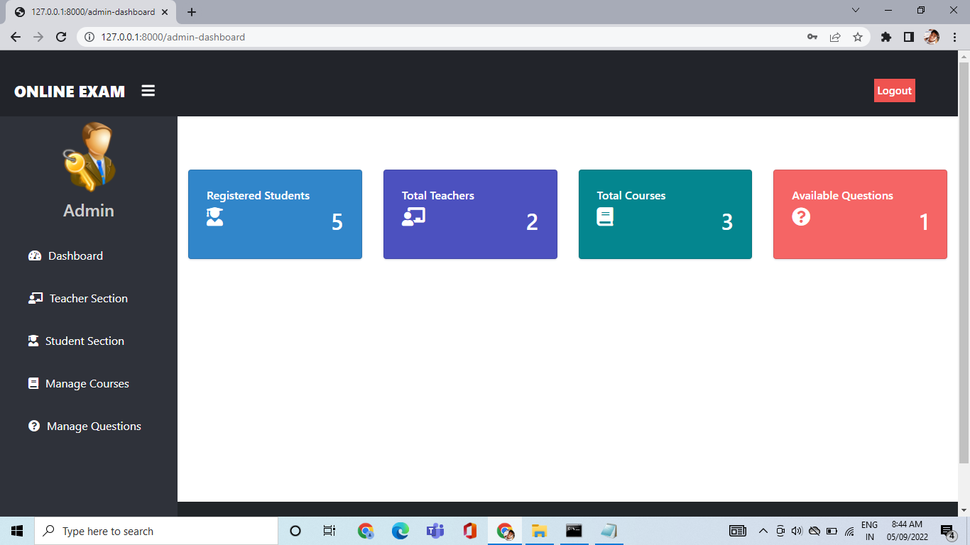

Fig 5.6 Screenshot 5

**5.7 Functional Programming**

Functional programming is style of programming language, which uses the concepts of mathematical functions. A function in mathematics should always produce the same result on receiving the same argument. In procedural languages, the flow of the program runs through procedures, i.e., the control of program is transferred to the called procedure. While control flow is transferring from one procedure to another, the program changes its state. In procedural programming, it is possible for a procedure to produce different results when it is called with the same argument, as the program itself can be in different state while calling it. This is a property as well as a drawback of procedural programming, in which the sequence or timing of the procedure execution becomes important. Functional programming provides means of computation as mathematical functions, which produces results irrespective of program state. This makes it possible to predict the behavior of the program.

**CONCLUSION & FUTURE WORK CHAPTER 6**

**6.1 Conclusion**

An online examination management system is the way of the future. It is not a revolutionizing of an existing system, instead of enhancement of it. An online examination management system is the way of the future. It is not a revolutionizing of an existing system, instead of enhancement of it. Online examination system is a user-friendly system, which is very easy and convenient to use. The system is complete in the sense that it is operational and it is tested by entering data and getting the reports in proper order. The key concept is to minimize the amount of paper and convert all forms of documentation to digital form. It can observe that the information required can be obtained with ease and accuracy in the computerized system. The user with minimum knowledge about computer can able operate the system easily. The system also produces brief result required by the management.

* 1. **Limitation of project**
* **Requires Stable Internet Connection**

One of the most demotivating facts of an online exam can be the internet bandwidth, which it requires at the student’s end to complete their exams

* **Requires A Device for Online Examination**

To give an exam online, the students must have a device, mobile phone, computer, or laptop. This requirement can make it impossible to opt for an online exam for those students who are not financially stable

* **Poor Correlation with Understanding System**

The time limit within which the students have to attempt the exam only enables them to assess their speed and not understand.

* **Hurdle for Students Not Technically Equipped**

India is still a developing country, and the percentage of illiterates in our country is high. In light of this background, an online exam for getting admission into any college or further promotion into the next academic year can be a challenge.

**6.3 Future enhancement**

Technological advancements in this era of digitization along with being a boon to the world have been advantageous to the educational sector too. The introduction of online examination system replaced the conventional system of assessment. The various examination conducting agencies are now able to evaluate the test takers freely and cost effective through computer based. Today’s article discusses the current scope and objectives of an online examination system also with future. Before proceeding further let us understand the concept of online examination software. Exam software allows users to take online tests and automatically generate results based on the answers marked by the users.

**BIBLIOGRAPHY & REFERENCES CHAPTER 7**

* <https://www.codester.com/items/4133/online-examination-system-php-exam-system-script>
* <https://thinkexam.com/blog/introduction-online-examination-system-how-does-it-workits-pros-cons/>
* <https://github.com/rishank-shah/Exam-Portal>
* <https://www.researchgate.net/publication/317306939_Online_Examination_System>
* <https://www.semanticscholar.org/paper/Design-of-a-Student%E2%80%99s-Online>